🧭 Phase 3 — Overview (What You’ll Learn)
🎯 Goal
Add a database layer to your architecture and understand high availability + replication

🔑 Topics Covered
1. Amazon RDS Basics
- Create DB instance
- Connect from EC2
- Store & retrieve data

2. Single-AZ vs Multi-AZ
- Single AZ:
  - One DB instance
  - No failover
- Multi-AZ:
  - Primary + standby
  - Automatic failover

3. Failover & Standby Promotion
- Simulate failure
- Observe automatic switch
- Understand downtime behavior

4. Read Replica
- Create replica from primary
- Read scaling
- Cross-AZ / cross-region concept

5. Promote Read Replica to Master
- Manual promotion
- Independent DB creation

🧠 What You Will Achieve
After Phase 3:
App (EC2) → Database (RDS)
You’ll understand:
- Backend data flow
- High availability in DB
- Read vs write separation

🏗️ Architecture After Phase 3
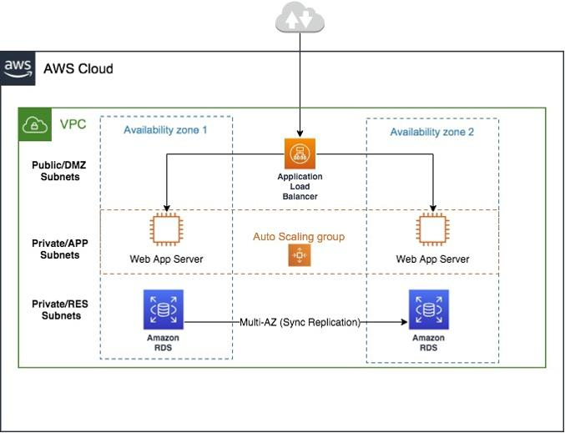
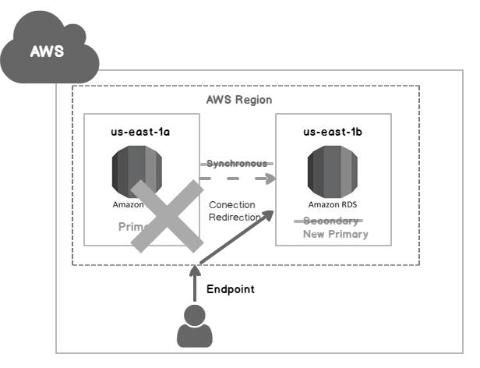
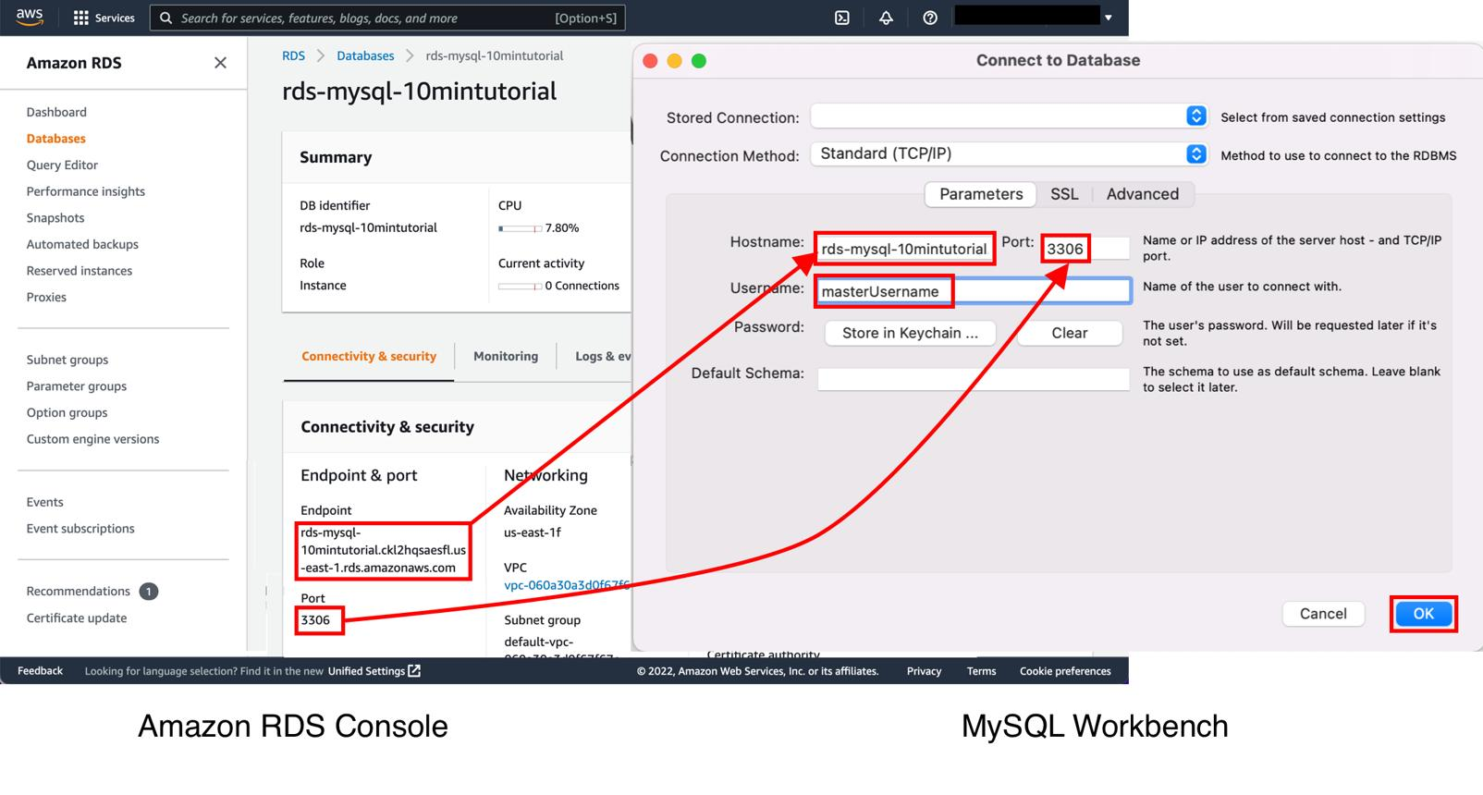
6

🚀 PHASE 3 SOP (GitHub Ready)

📘 SOP: AWS RDS (Single-AZ, Multi-AZ, Read Replica, Promotion)

🧭 Objective
Build and test database layer:
EC2 → RDS (Primary DB)

🔧 Prerequisites
- Phase 2 completed
- EC2 instance available (for DB access)
- VPC already created

🚀 Step 1: Create RDS (Single-AZ)
📍 Navigation
AWS Console → RDS → Create Database

⚙️ Configuration
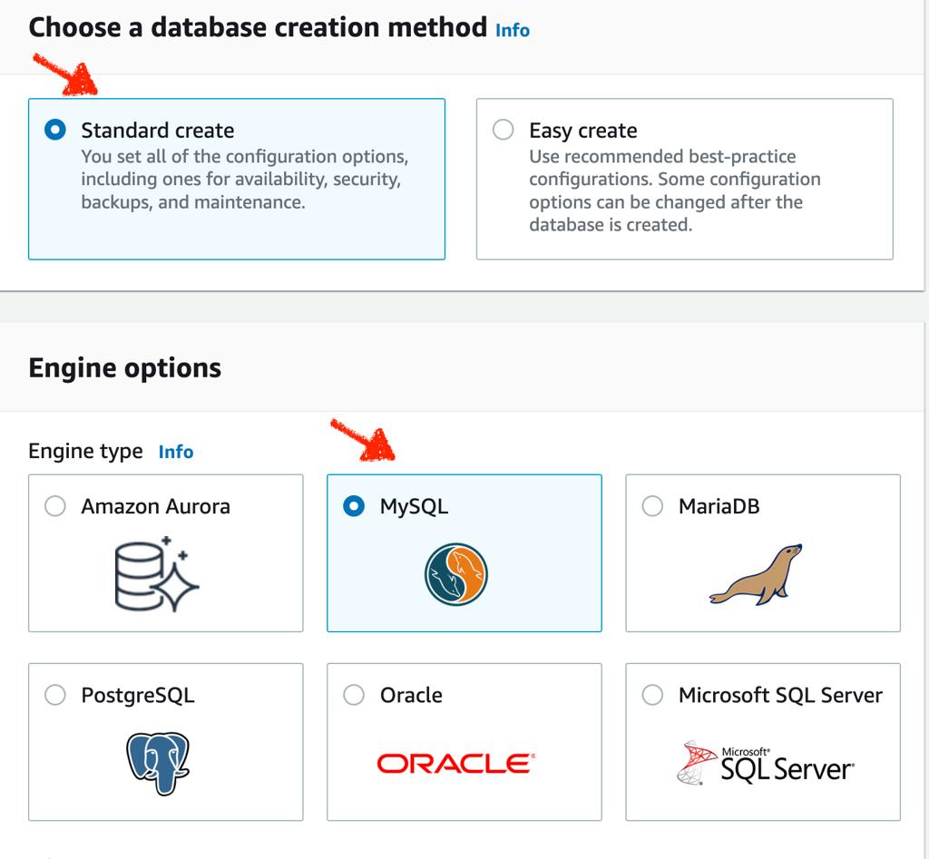
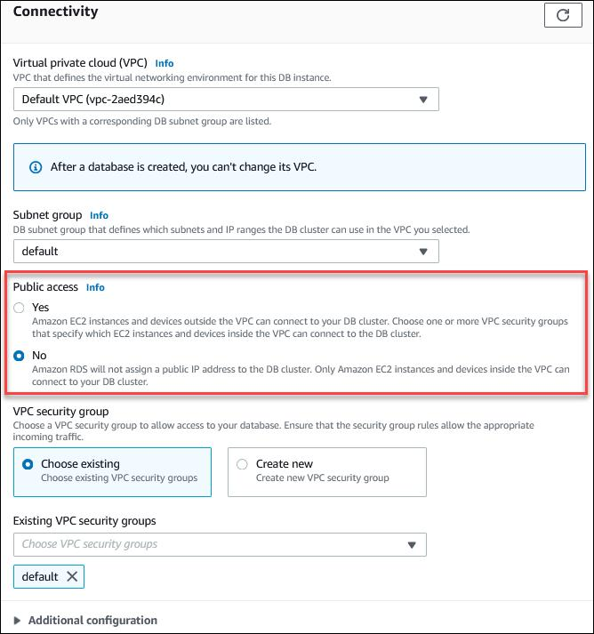
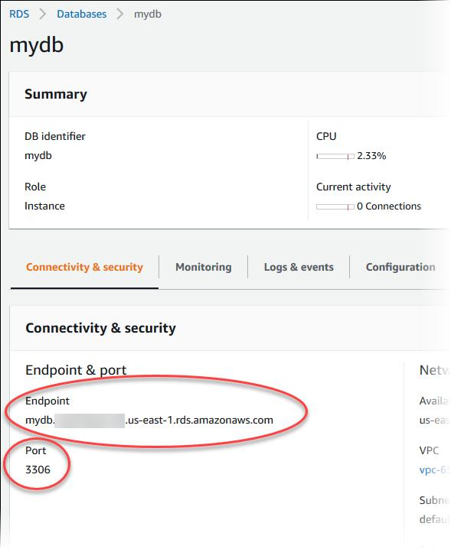
6

🔹 Engine Options
Setting | Value
Engine | MySQL
Version | Default

🔹 Templates
- Choose: Free tier (if available)

🔹 DB Settings
Parameter | Value
DB Identifier | mydb
Master Username | admin
Password | Strong password

🔹 Instance Config
Parameter | Value
DB Class | db.t3.micro

🔹 Connectivity
Setting | Value
VPC | Same as EC2
Public Access | YES (for lab)

🔹 Security Group
Allow:
MySQL/Aurora (3306) from EC2 security group

✅ Create DB
⏳ Wait ~5–10 mins

🔌 Step 2: Connect from EC2
📍 SSH into EC2
Install MySQL client:
sudo yum install mysql -y

🔗 Connect to DB
mysql -h <RDS-ENDPOINT> -u admin -p

🧪 Test DB
CREATE DATABASE testdb;
USE testdb;
CREATE TABLE users (id INT, name VARCHAR(50));
INSERT INTO users VALUES (1, 'AWS');
SELECT * FROM users;

✅ Expected Output
1 | AWS

🔁 Step 3: Convert to Multi-AZ
📍 Navigation
RDS → Modify DB

⚙️ Enable Multi-AZ
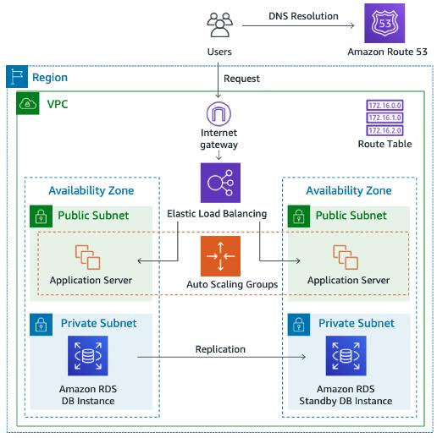
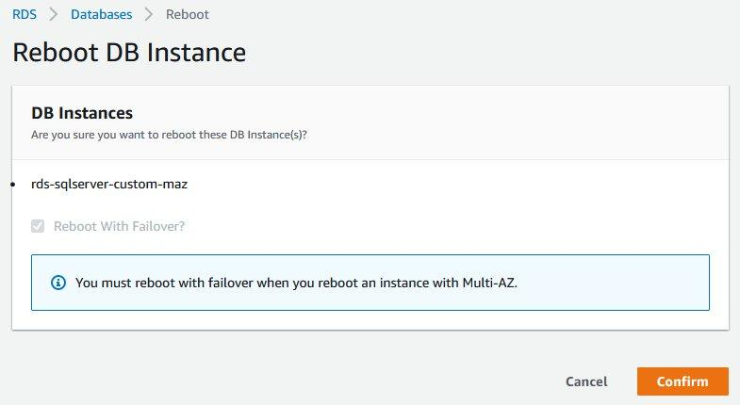
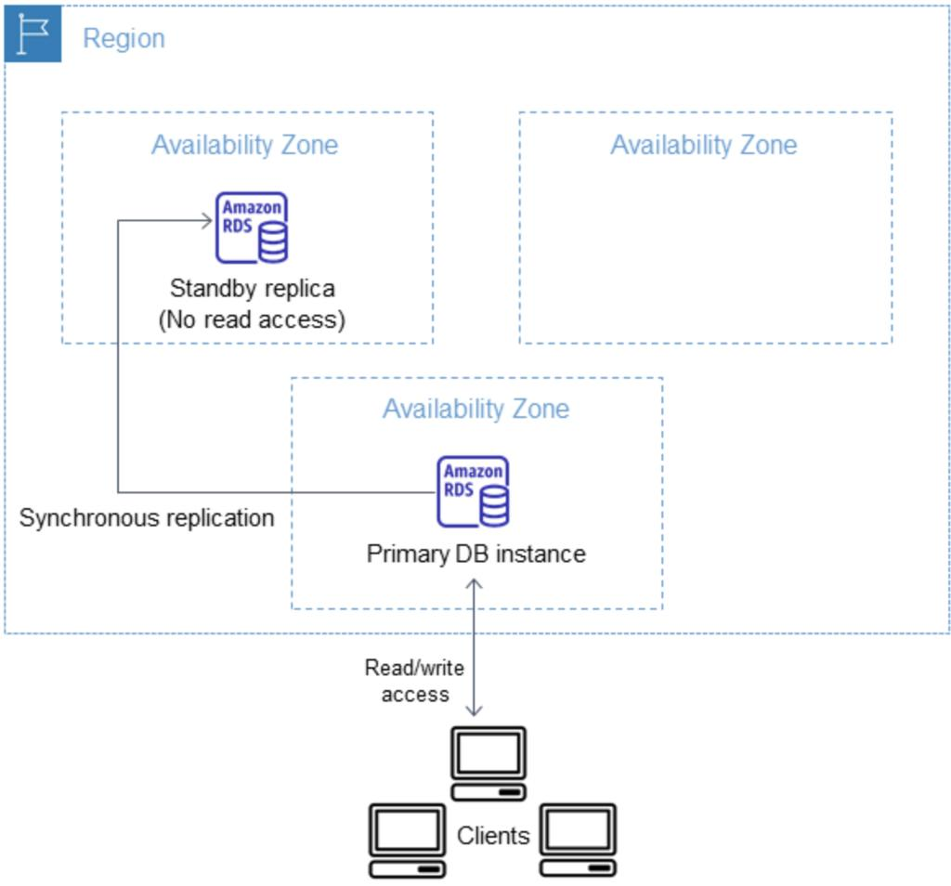
6

- Enable: Multi-AZ deployment
- Apply immediately

🧠 What Happens
Primary DB → Standby DB (different AZ)

🧪 Step 4: Test Failover
📍 Action
- RDS → Actions → Reboot with failover

🔍 Observe
- Endpoint remains same
- Backend instance switches

🎯 Result
Minimal downtime + automatic recovery

📖 Step 5: Create Read Replica
📍 Navigation
RDS → Actions → Create Read Replica

⚙️ Config
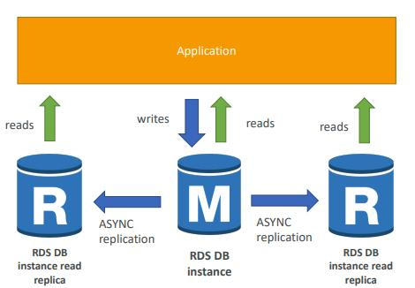
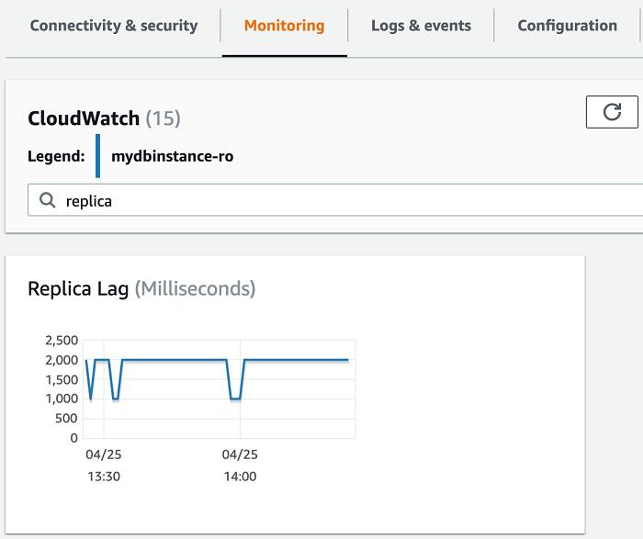
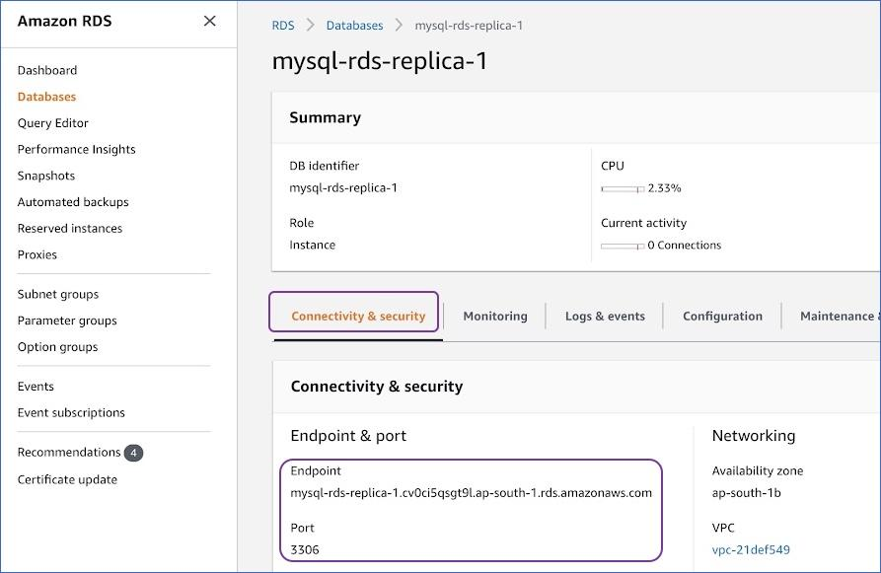
7

- Choose same DB
- Keep defaults
- Create replica

🧠 Concept
Primary → Writes
Replica → Reads

🧪 Step 6: Test Read Replica
- Connect to replica endpoint
- Try:
SELECT * FROM users;

👉 Try write:
INSERT INTO users VALUES (2, 'Test');
❌ Should fail (read-only)

🔄 Step 7: Promote Read Replica
📍 Navigation
RDS → Read Replica → Promote

🎯 Result
Replica → Independent Primary DB

🧠 Key Learnings
- Multi-AZ = High availability
- Read Replica = Scaling reads
- Promotion = Disaster recovery

🧹 Cleanup
- Delete:
  - RDS instances
  - Read replicas
⚠️ RDS costs more than EC2 — don’t forget cleanup

❓ Before You Start Phase 3
Just confirm:
👉 Do you want:
- MySQL (simple)
- Or PostgreSQL (more real-world)

🧭 Phase 3 Structure
🔹 Phase 3A (Now)
👉 RDS WITHOUT EC2
- Learn DB basics
- Connect directly (local / MySQL client)
- Multi-AZ
- Read replicas
- Promotion

🔹 Phase 3B (Next)
👉 RDS WITH EC2
- App/EC2 → DB connection
- Security groups (real-world)
- Private access

📘 SOP: Phase 3A — RDS (MySQL) WITHOUT EC2

🧭 Objective
Create and test a managed database:
Client → RDS (MySQL)

🏗️ Architecture Overview
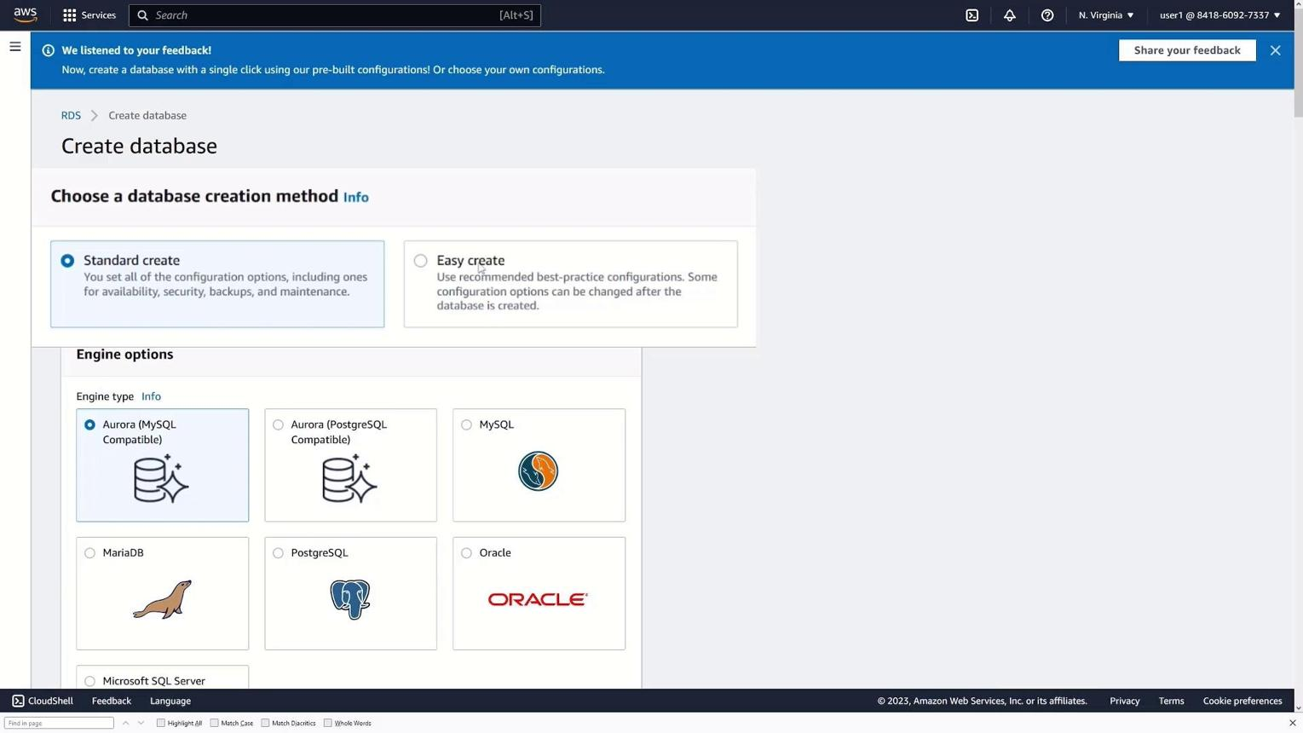
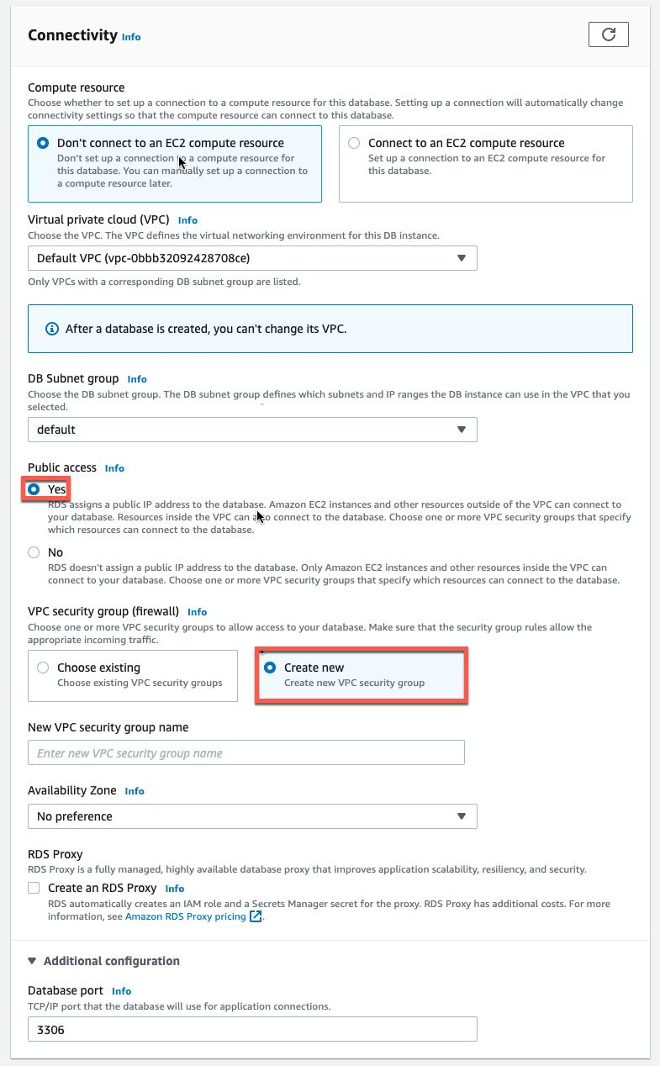
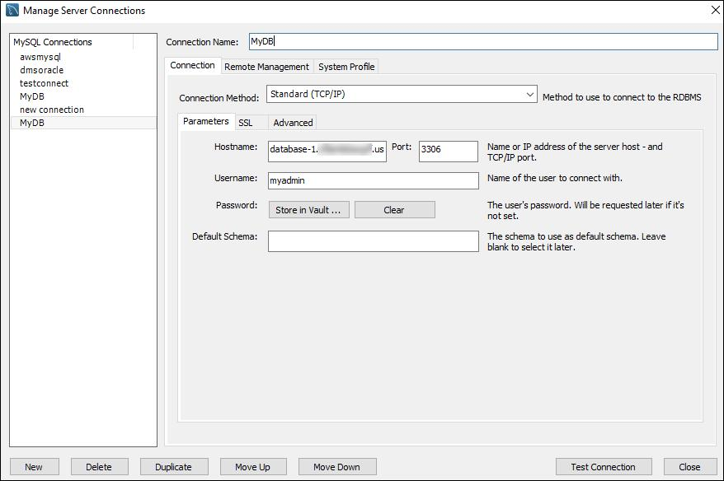
7

🔧 Prerequisites
- AWS account
- Local system with MySQL client installed
(or use CloudShell in AWS)

🚀 Step 1: Create RDS MySQL (Single-AZ)
📍 Navigation
AWS Console → RDS → Create Database

⚙️ Configuration
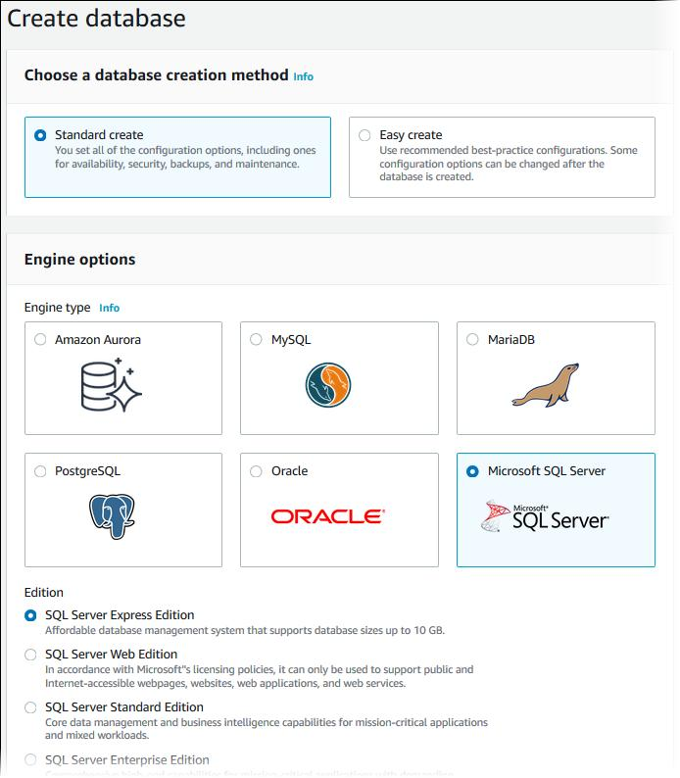
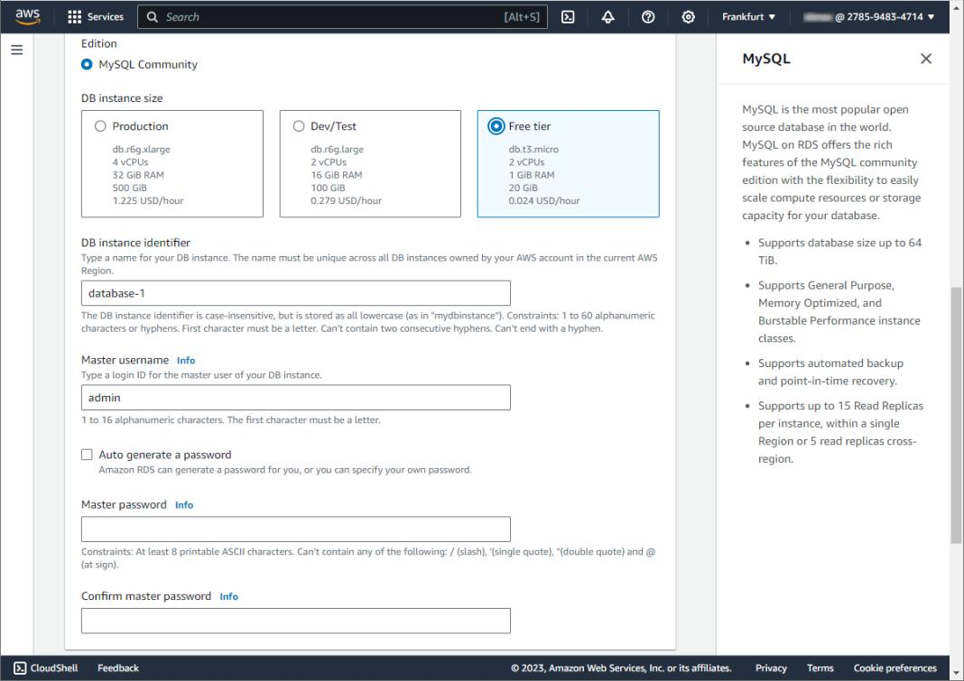

7

🔹 Engine
Setting | Value
Engine | MySQL
Version | Default

🔹 Template
👉 Choose:
Free tier

🔹 DB Settings
Parameter | Value
DB Name | mydb
Username | admin
Password | Strong password

🔹 Instance Configuration
Parameter | Value
Class | db.t3.micro

🔹 Connectivity (IMPORTANT)
Setting | Value
Public Access | YES
VPC | Default
Subnet | Default

🔹 Security Group
Allow:
MySQL (3306) → Your IP

✅ Create DB
⏳ Wait until status:
Available

🔌 Step 2: Connect to RDS (Without EC2)

Option 1: Using Local Machine
Install MySQL client if not installed.

🔗 Connect Command
mysql -h <RDS-ENDPOINT> -u admin -p

Example:
mysql -h mydb.xxxxxx.ap-south-1.rds.amazonaws.com -u admin -p

Option 2: Using AWS CloudShell (Easier)
- Open CloudShell
- Run:
sudo yum install mysql -y
mysql -h <endpoint> -u admin -p

🧪 Step 3: Create Data
Run:
CREATE DATABASE labdb;
USE labdb;
CREATE TABLE users (
id INT,
name VARCHAR(50)
);
INSERT INTO users VALUES (1, 'phase3');
SELECT * FROM users;

✅ Expected Output
1 | phase3

🔁 Step 4: Enable Multi-AZ
📍 Navigation
RDS → Databases → Select DB → Modify

⚙️ Configuration
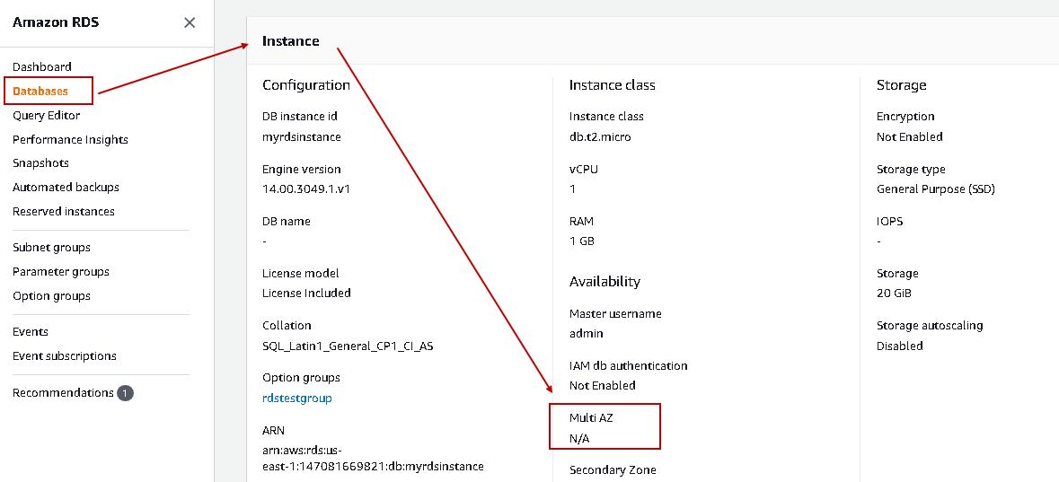


8

- Enable:
Multi-AZ deployment
- Apply immediately

🧠 What Happens
Primary DB → Standby DB (another AZ)

🧪 Step 5: Test Failover
📍 Action
RDS → Actions →
👉 Reboot with failover

🔍 Observe
- Endpoint remains SAME
- DB instance behind changes

🎯 Result
Automatic failover successful

📖 Step 6: Create Read Replica
📍 Navigation
RDS → Select DB → Actions →
👉 Create read replica

⚙️ Config
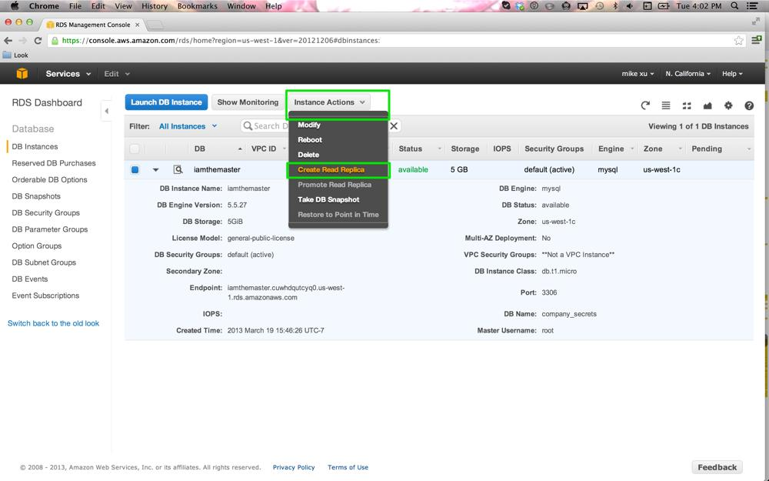
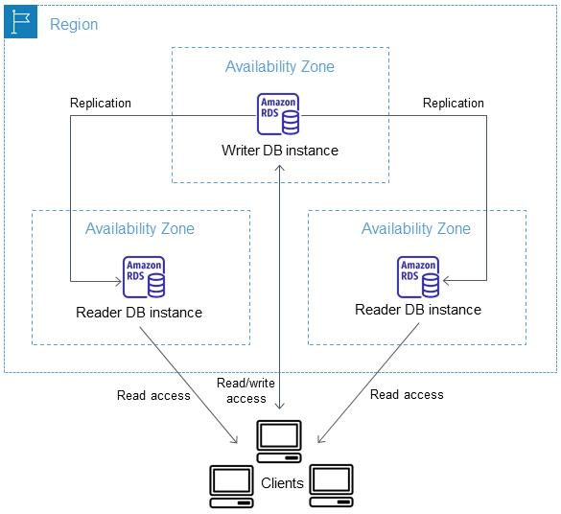

6

- Keep defaults
- Create replica

🧠 Concept
Primary → Writes
Replica → Reads

🧪 Step 7: Test Replica
Connect to replica endpoint:
mysql -h <replica-endpoint> -u admin -p

Try:
SELECT * FROM labdb.users;
✅ Works

Try:
INSERT INTO users VALUES (2, 'fail');
❌ Fails (read-only)

🔄 Step 8: Promote Read Replica
📍 Navigation
RDS → Replica → Actions →
👉 Promote

🎯 Result
Replica becomes independent DB

🧠 Key Learnings
Feature | Purpose
Single-AZ | Basic DB
Multi-AZ | High availability
Read Replica | Scale reads
Promotion | Disaster recovery

🧹 Cleanup (IMPORTANT 💰)
Delete:
- Primary DB
- Read replica
⚠️ RDS is costly if left running

📌 GitHub README Suggestion
## Phase 3A: RDS (Standalone)
- MySQL DB setup
- Multi-AZ configuration
- Failover testing
- Read replica setup
- Promotion

Phase 3B — EC2 ↔ RDS (Private & Secure)

🧭 Objective
Build secure communication:
EC2 (App) → RDS (MySQL)
👉 No public DB exposure
👉 Controlled via security groups

🏗️ Architecture Overview
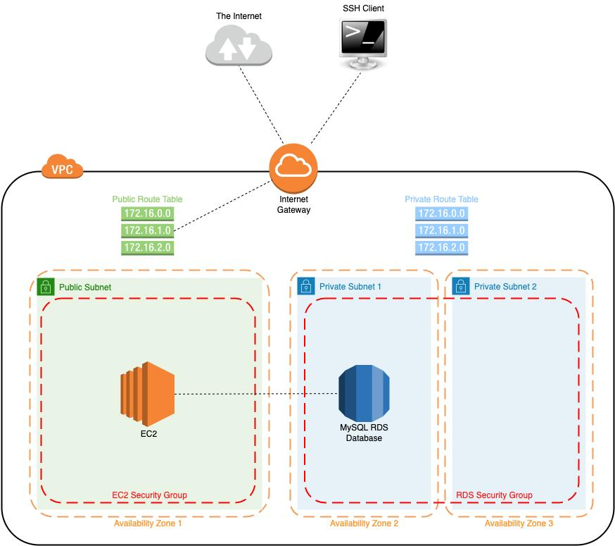

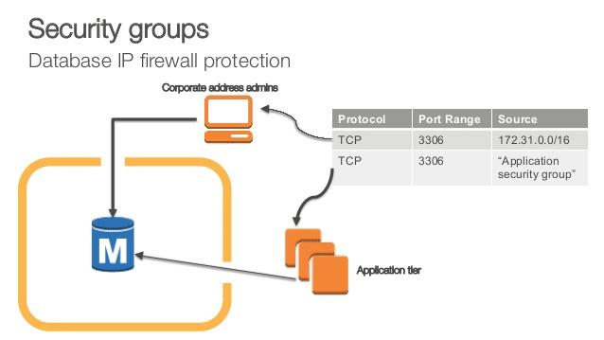
7

🔧 Prerequisites
- RDS created (Phase 3A)
- EC2 instance available (can reuse or create new)
- Same VPC

🚀 Step 1: Prepare RDS (Make it Private)
📍 Check RDS Settings
Go to:
👉 RDS → Database → Connectivity

🔹 Update if needed:
Setting | Value
Public Access | ❌ NO
VPC | Same as EC2

⚠️ If already public
👉 You can still continue for learning
(we’ll secure via SG anyway)

🔐 Step 2: Configure Security Groups (MOST IMPORTANT)

🔹 2.1 Identify Security Groups
- EC2 SG → ec2-sg
- RDS SG → rds-sg

🔹 2.2 Update RDS Security Group
Go to:
👉 EC2 → Security Groups → rds-sg

Add Inbound Rule:
Type: MySQL/Aurora
Port: 3306
Source: ec2-sg (NOT 0.0.0.0/0)

🎯 Result
Only EC2 → can access RDS ✅
Internet → blocked ❌
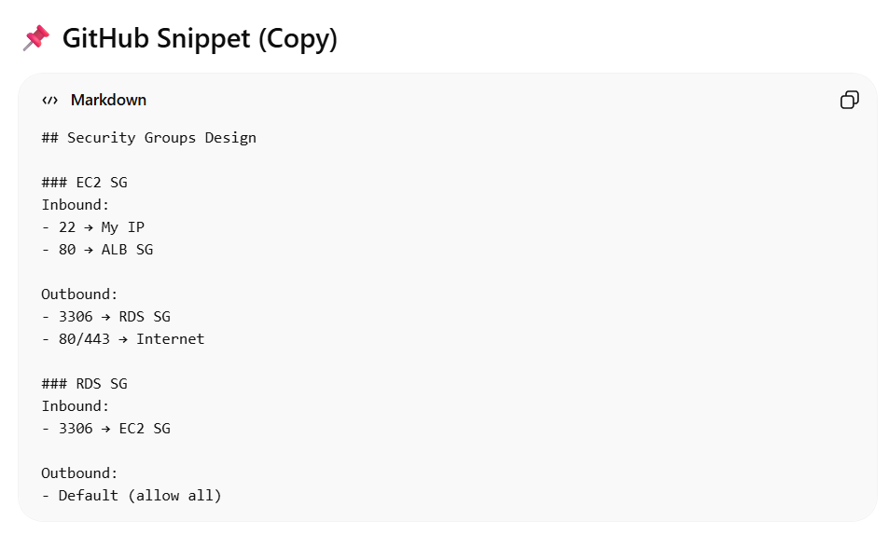

🚀 Step 3: Connect from EC2

📍 SSH into EC2
ssh -i key.pem ec2-user@<public-ip>

📦 Install MySQL Client
sudo yum install mysql -y

🔗 Connect to RDS
mysql -h <RDS-ENDPOINT> -u admin -p

🧪 Test Connection
USE labdb;
SELECT * FROM users;

✅ Expected Output
1 | phase3
2 | aws

🔍 Step 4: Verify Security (IMPORTANT TEST)

❌ Try from your local system
mysql -h <RDS-ENDPOINT> -u admin -p

Expected:
Connection timed out ❌

🎯 Meaning
RDS is NOT publicly accessible ✅

🧠 Step 5: Understand the Flow
Browser → ALB → EC2 → RDS

👉 Now:
- EC2 = Application layer
- RDS = Data layer

🔐 Step 6 (Optional but Important): Use SSL from EC2
mysql -h <endpoint> \
--ssl-ca /path/to/cert \
-u admin -p

🧠 Key Concepts Learned

🔹 Security Groups as Firewall
EC2 SG → allows SSH/HTTP
RDS SG → allows only EC2

🔹 Private DB
No public access
Only internal communication

🔹 Layered Architecture
App layer → DB layer separation

🧪 Practice Exercises
- Remove SG rule → test connection fails
- Add wrong SG → debug
- Try connecting from another EC2 → fails

🧹 Cleanup (Optional)
- Stop EC2 if not used
- Keep RDS only if continuing

📌 GitHub README Suggestion
## Phase 3B: EC2 to RDS (Secure Connection)
- Private DB setup
- Security group configuration
- EC2 → RDS connection
- Security validation

🎯 What You Achieved
You now have:
Compute + Database integration ✅
Secure architecture ✅
Production-style networking ✅

